|  |
| --- |
| SNHU CS-255-H2973 |
| System Design Document |
| Project Two |

|  |
| --- |
| Bryce Jensen  12-2-2023 |

## UML Diagrams

### UML Use Case Diagram

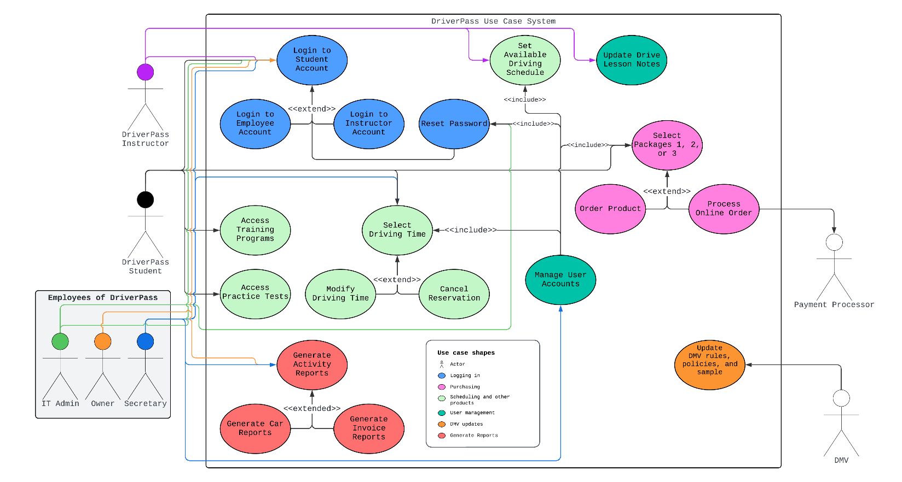

*DriverPass Use Case System Diagram*

### UML Activity Diagrams

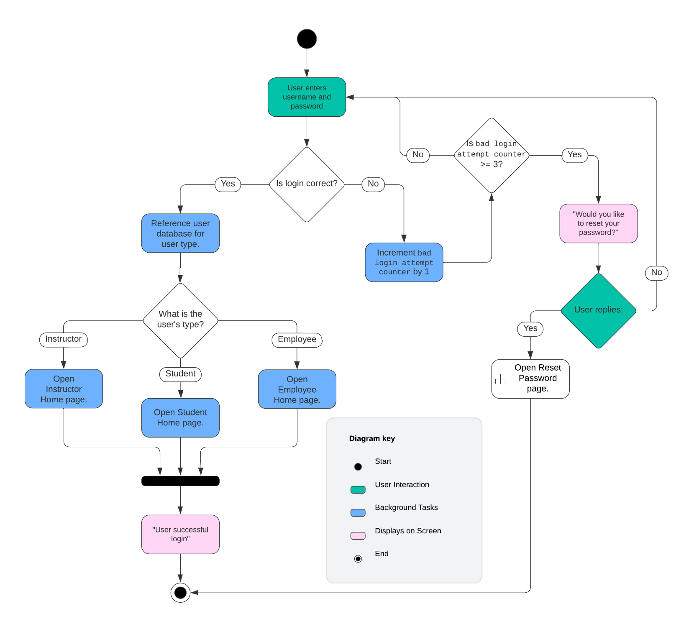

*Login Use Case Activity Diagram*

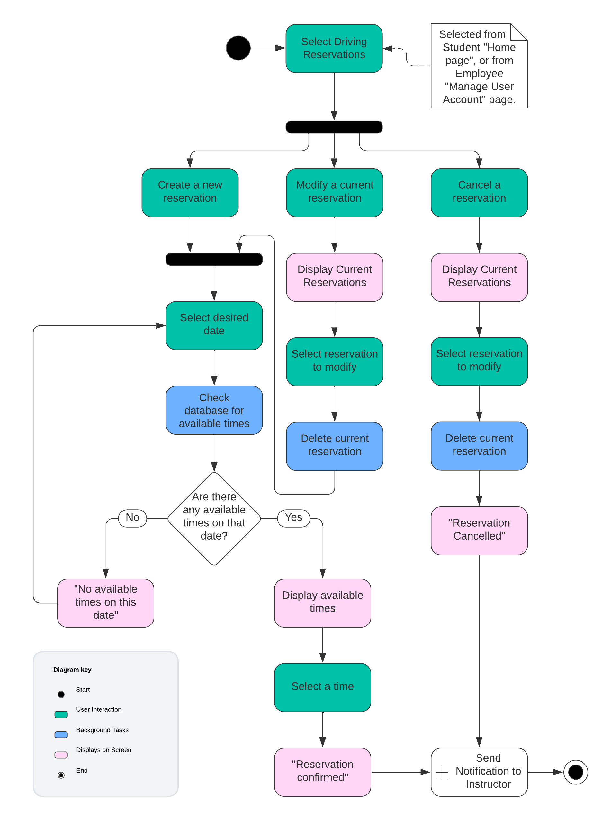

*Reservation Use Case Activity Diagram*

### UML Sequence Diagram

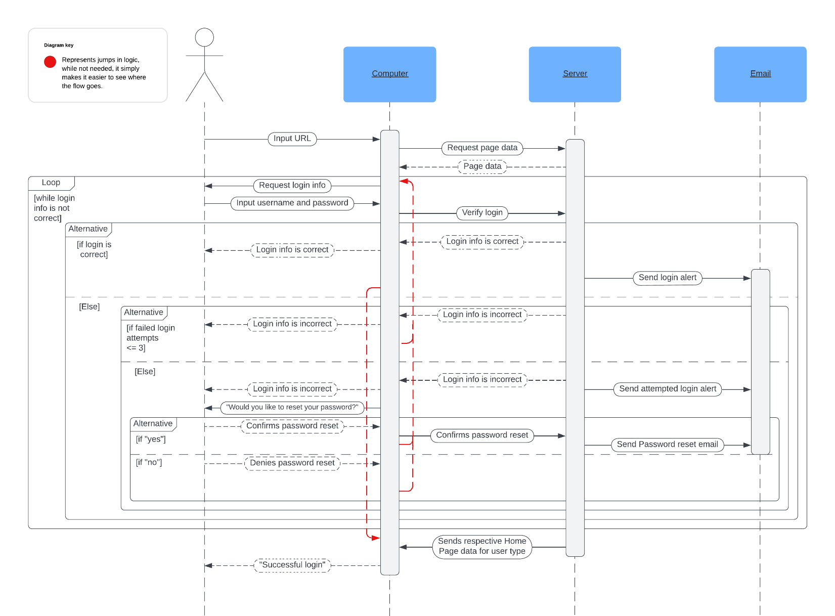

*Login Use Case Sequence Diagram*

### UML Class Diagram

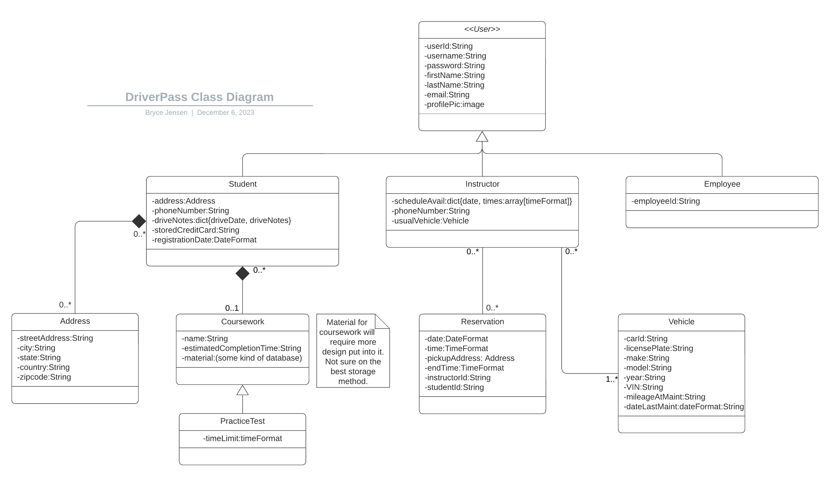

## Technical Requirements

*[Based on the diagrams you have created, describe the technical requirements of your system. These requirements should address the required hardware, software, tools, and infrastructure necessary for your system design.]*

* The DriverPass system will run as a SaaS (Software as a Service) program.
  + Users will access it from any major browser updated in the last 5 years.
  + At a minimum, it will be compatible with the latest versions of Chrome, Firefox, and Safari.
    - If not compatible with a browser, an error message should be displayed with an explanation.
  + It will run from the cloud. The DriverPass client will not need to host or maintain a server at their location.
* Security: addresses and payment information will be used.
  + All user data will be encrypted using AES-256.
  + Multi-factor authentication (MFA) will be an option for all users.
  + Different user roles will have specific access permissions.
* The UI should follow the company's design guidelines. Smaller screen sizes will be accounted for.
* The system will perform daily backups, these will be stored for a minimum of 30 days for any troubleshooting needs.
* For payments, DriverPass will need to access a payment service. This will need to be shared with us so we can ensure compatibility.